

Application for Leave of Absence
At Ackworth School, every day provides a full and comprehensive curricular and co-curricular education, enriching our pupils’ day for an exceptional, holistic and inclusive Quaker education. To reflect this, we have generous school holidays allowing pupils to recharge and rest.

We would always encourage 100% attendance throughout the school term-time, due to the proven links between attendance and future prospects in examinations and in careers.

If a pupil is absent from school, they are expected to make every effort to catch up on missed work to minimise the impact of this absence.

For an absence of less than one day, e.g. for a medical appointment, please contact your child’s tutor/class teacher.

For absences of more than 1 day, please complete the form below and send to attendance@ackworthschool.com.

Name of Pupil

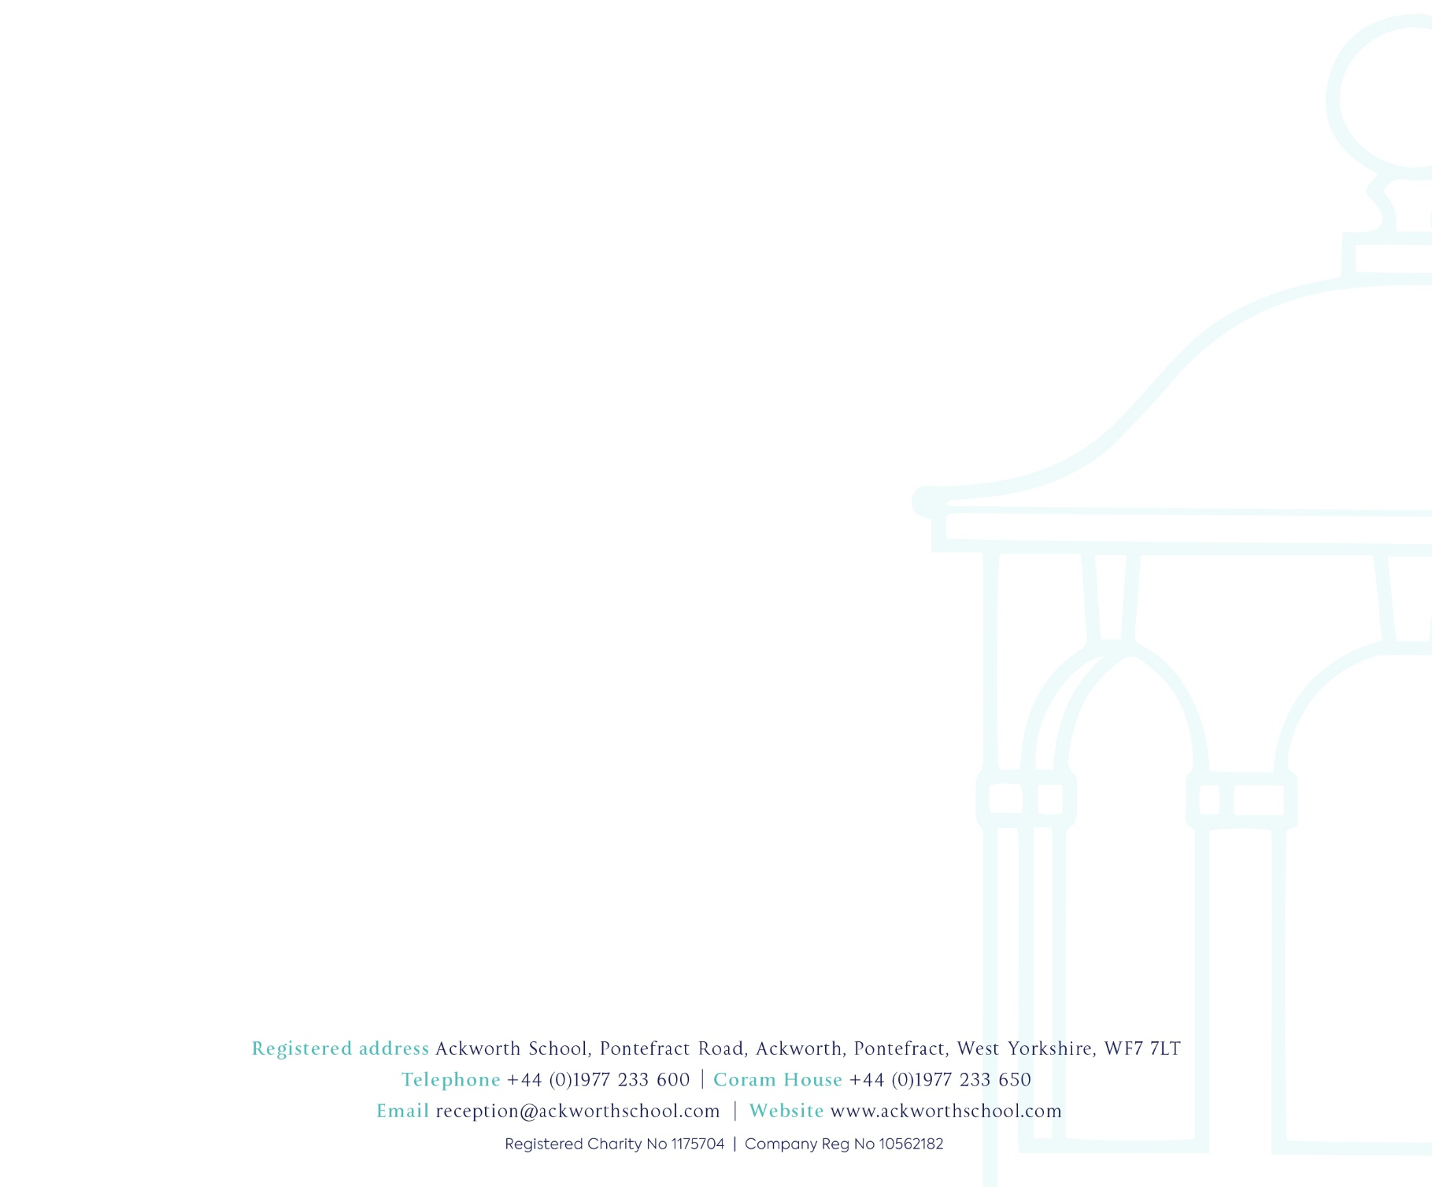
Year group

Absence dates requested | From | To
Days absent from school

Reason for absence

Signed:

Relationship to Child:

Dated:

Contact email address:

You will be contacted as soon as possible with confirmation of whether the absence has been approved or not.

